

EYFS POLICY

No: 1

Reviewed: March 2025


EYFS at St Andrew’s Primary School
Rationale
St Andrew’s School is a place where everyone is valued and cared about. Each child’s learning is enhanced through teaching them effectively. This takes place in an environment that provides intellectual, emotional and physical safety, is sensitive to their needs, challenging and allows success to be celebrated.

Aims
This policy aims to ensure:
- That children access a broad and balanced curriculum that gives them a range of knowledge and skills needed for good progress throughout school and life
- Quality and consistency in teaching and learning so that every child makes good progress and no child gets left behind
- A close working partnership between staff, parents and/or carers
- Every child is included and supported through equality of opportunity and anti-discriminatory practice

Legislation
This policy is based on requirements set out in the statutory framework for the Early Years Foundation Stage (EYFS) for 2023.

Structure of the EYFS

In the policy the term ‘setting’ refers to the Early Years educational provision at our school. EYFS is available to children who enter school from September of the academic year in which they will turn five years old. These children are in the final year of the EYFS. In the National Curriculum this is referred to as the Reception Year. In the policy the term ‘practitioner’ refers to the members of staff working with children within the setting.

Curriculum
The curriculum we plan and teach to our pupils is demanding and ambitious; we know this because in the Early Years, the curriculum has bee designed and developed in line with the EYFS Framework and is broken down using Development Matters. The EYFS framework includes seven interconnected areas of learning and development that are equally important. There are three prime areas which are important for igniting curiosity and enthusiasm for learning, for building children’s capacity to learn and to form relationships to thrive.

The prime areas are:
- Communication and language
- Physical development
- Personal, social and emotional development
These prime areas are strengthened and applied through four specific areas:
- Literacy
- Mathematics
- Understanding the world
- Expressive arts and design

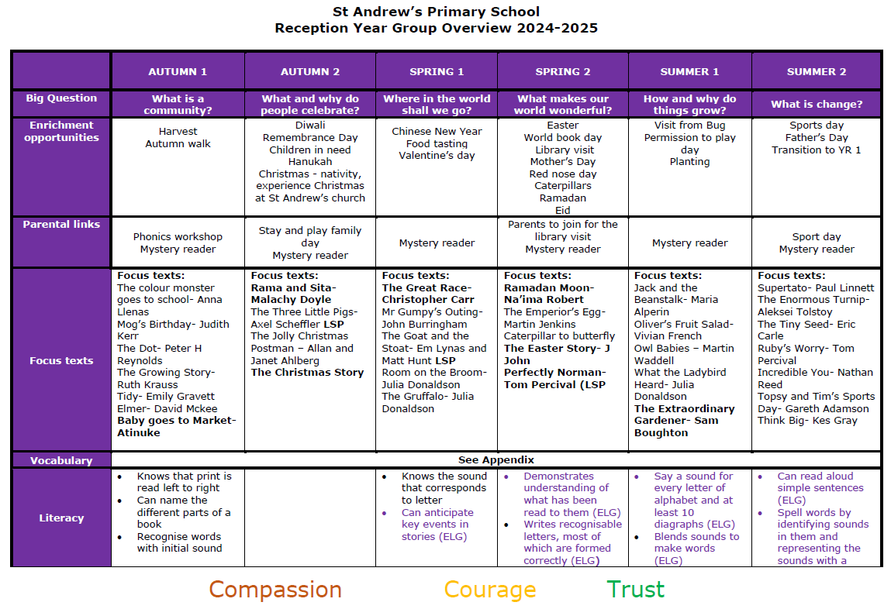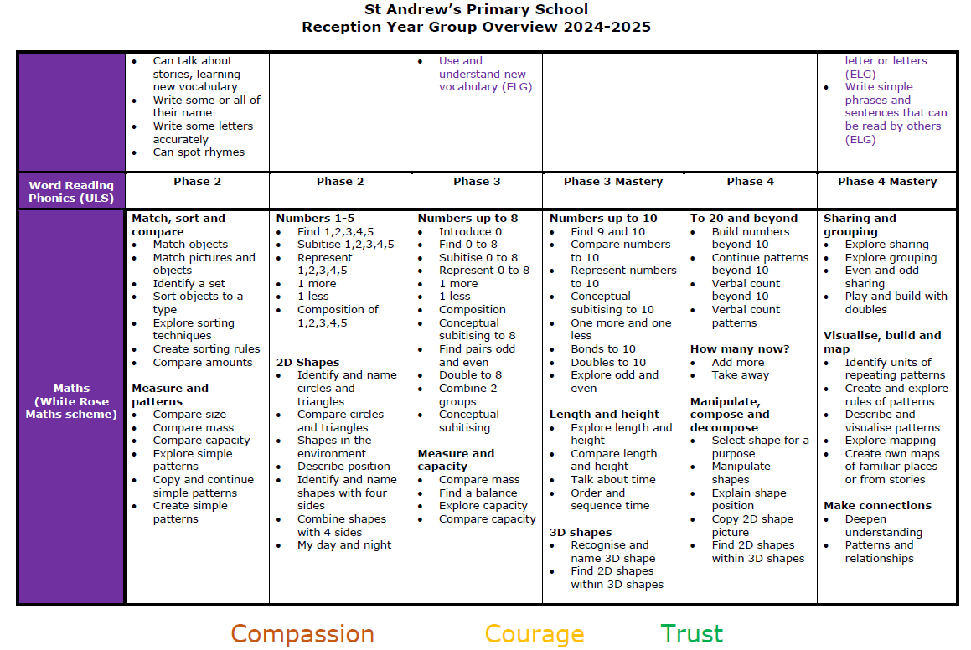
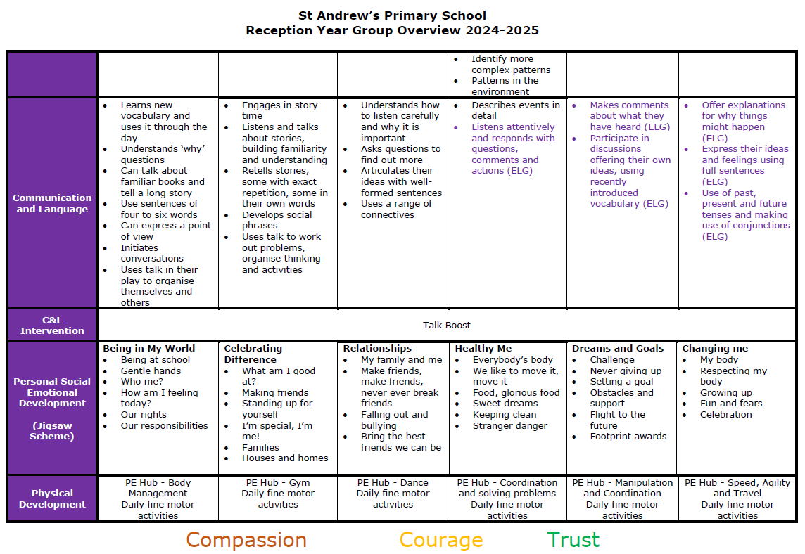
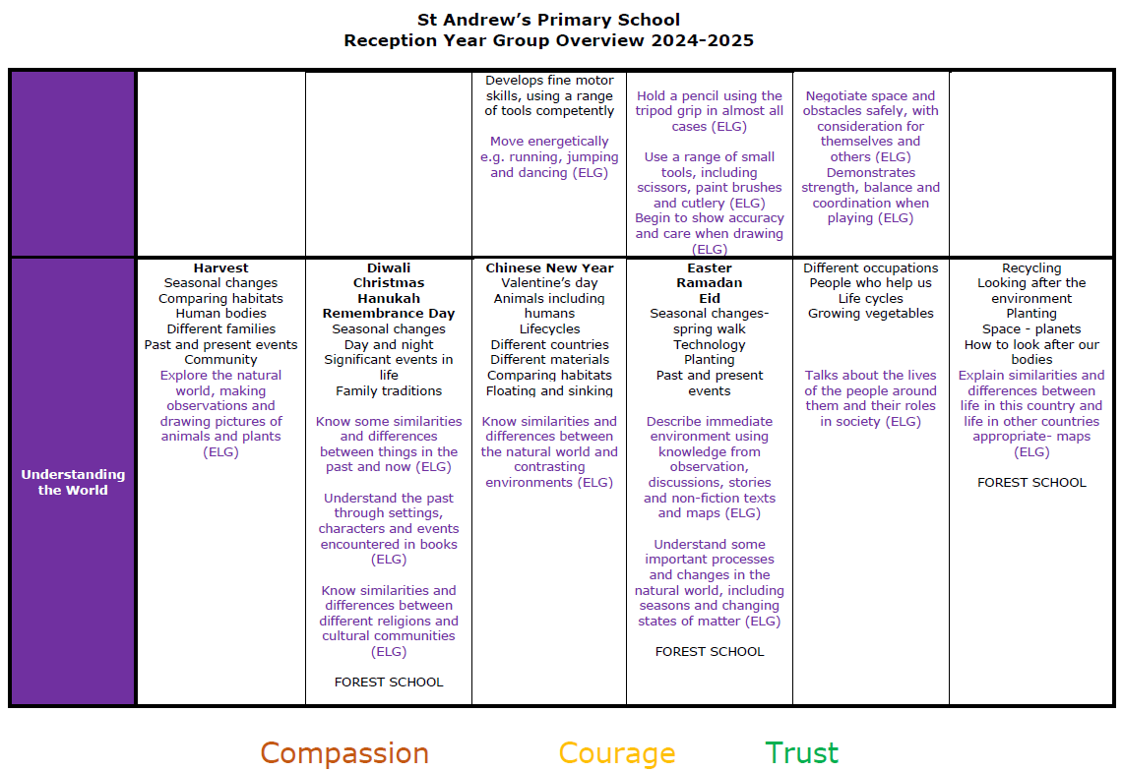
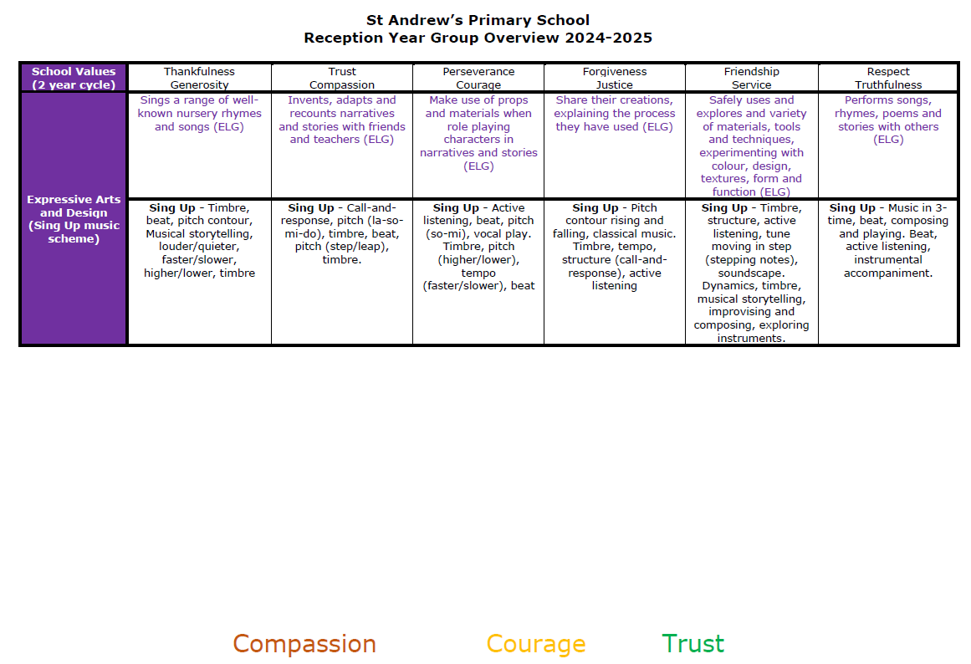

Teaching
Each area of learning and development is implemented through planned, purposeful play and through a mix of adult-led and child-initiated activities. Staff respond to each child’s emerging needs and interests, guiding their development through warm, positive interaction.
As children progress, and as their development allows, the balance gradually shifts towards more adult-led activities to help children prepare for more formal learning and be ready for Year 1.

Assessment
At St Andrew’s, ongoing assessment is an integral part of learning and development processes. Within the first six weeks that a child starts Reception, staff will administer the Reception Baseline Assessment (RBA).
Effective assessment in EYFS at St Andrew’s involves:
- Maximum use of formative assessment - cold calling; think, pair, share; show me boards; probing questions; no opt out; low stakes testing are all strategies which are used rigorously and intelligently by adults throughout sessions to ‘check for understanding’.
- Responsive teaching - once teachers understand how children are responding to the planned session, they can respond appropriately. If children are keeping up, the learning can move on, where they are not additional instruction should be given either at whole class, group or individual level depending upon the needs of pupils.
- Use of summative assessment - In reading and writing, teachers moderate with other schools within our Trust in terms 3 and 5 against the end of year writing standards. In phonics, we formally test taught sounds, segmenting and blending weekly.

Throughout lessons and guided practice pupils’ are given opportunities to ‘tick or fix’ their work. This is about feedback as actions. When pupils’ correct mistakes or edit their work, they engage with the learning process.
At the end of the Reception, staff complete the EYFS profile for each child. Pupils’ are assessed against the 17 Early Learning Goals, indicating whether they are:
- Meeting expected levels of development
- Not yet reaching expected levels (‘emerging’)
The profile is moderated internally (referring to the Development Matters guidance) and in partnership with other schools within our Trust, to ensure consistent assessment judgements. EYFS profile data is submitted to the local authority.

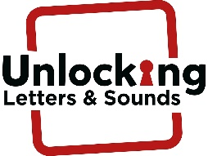
Early Reading at St Andrew’s Primary
At St Andrew’s, we teach for mastery through explicit instruction. Each element of reading is explicitly taught so that they become proficient in the skills they will need to independently apply.
 | Phonics lesson | Guided reading | 1 to 1 reading | Reading for choice | Story telling | Home reading
EYFS | Daily 25 min session | 3 sessions a week | 2 to 3 times a week with an adult | Opportunity to access books within the book corner and learning environment daily | 2 to 3 times a day | 5 times a week

The phonics teaching scheme is set out by unlocking “Letters and Sounds” which was validated by the DfE in December 2021. We begin teaching phonics in the first few weeks of term 1 in Reception and children make rapid progress in their reading journey. Children begin to learn the main sounds heard in the English Language and how they can be represented, as well as learning ‘Common Exception’ words for Phases 2, 3 and 4. They use these sounds to read and write simple words, captions and sentences. Children leave Reception being able to apply the phonemes taught within Phase 2, 3 and 4.

EYFS Phonics Teaching Sequence
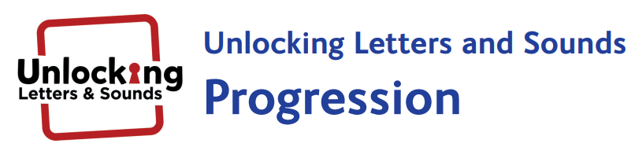
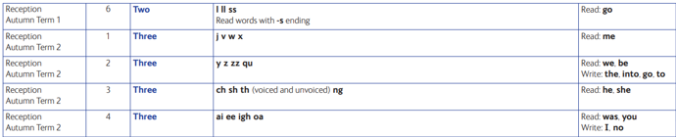
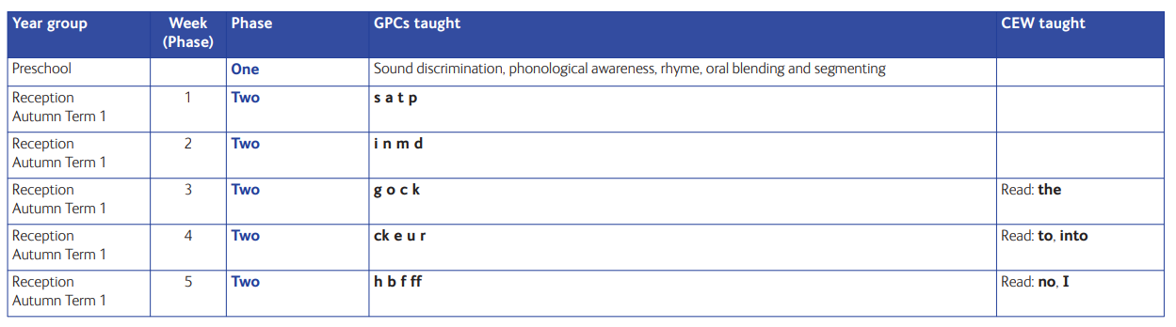

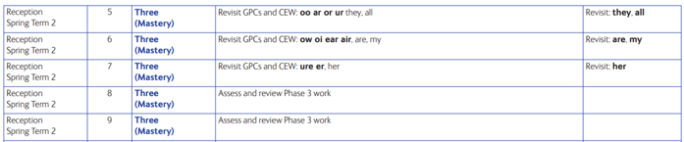
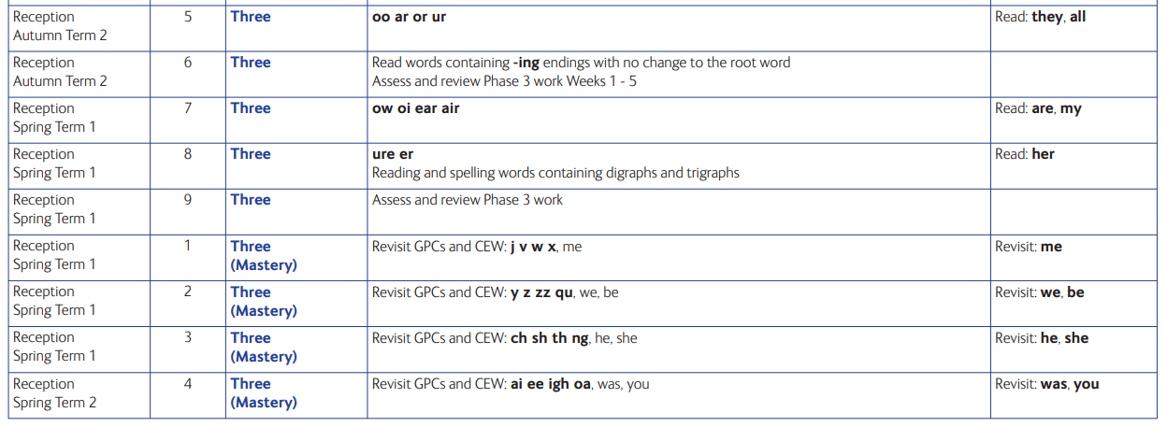

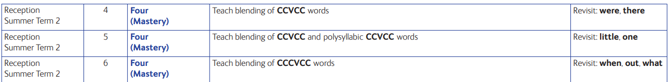
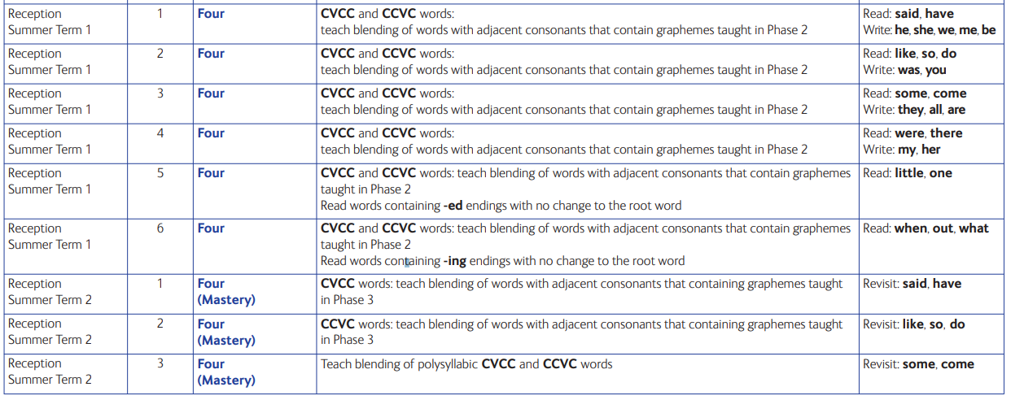

Assessment of Reading
In addition to adjusting teaching minute by minute in the classroom, in order to ensure that children are learning, retaining and accurately applying phonics we systematically use phonics assessments to test: recognition of individual sounds; how children segment sounds in words; how they blend them when reading them before looking at their application in writing words using taught sounds. This information is used by teachers as part of an assessment-led approach so we do not move on until pupils have mastered what has already been taught.
Writing at St Andrew’s Primary
In EYFS, the teaching of writing, has been carefully considered to enable our pupils’ to be confident and creative writers. We follow the LSP writing progression which ensures that throughout their time at St Andrew’s they develop all the necessary skills to meet the expectations for the taught age and stage of development. Transcription and dictation matches their phonics attainment in the way that decodable books do to support early reading. We also want our new writers to develop their composition skills in order that they can use and manipulate language for different audiences and purposes – and these need to be beyond their phonics skills. So oral comprehension allows them to develop these skills (in the same way that reading stories aloud supports pupils to develop comprehension skills using books beyond their decoding attainment) so that, when they can apply their transcriptional skills they have the composition skills needed to create texts that entertain and inform.

VGP = Vocabulary, grammar and punctuation
Comp = Composition
 | Handwriting/ fine motor control | Phonics | Guided Practise Writing Sessions | 1 to 1 reading with an adult | Independent writing
EYFS | Daily | Daily | 3 times a week progressing to 5 by term 4 | 2 to 3 times a week | Writing opportunities available throughout play
Opportunities for writing throughout the week


Maths at St Andrew’s
All children take part in a daily taught maths session which focusses on mastering the fundamental skills needed to become confident mathematicians. Pupils’ spend the majority of their time developing a deep conceptual understanding of key number facts. They then learn efficient and accurate methods of counting before moving onto solving problems using a range of concrete resources and pictures and finally moving onto the abstract. At St Andrew’s we follow the White Rose Maths Scheme of work which is used throughout the school.
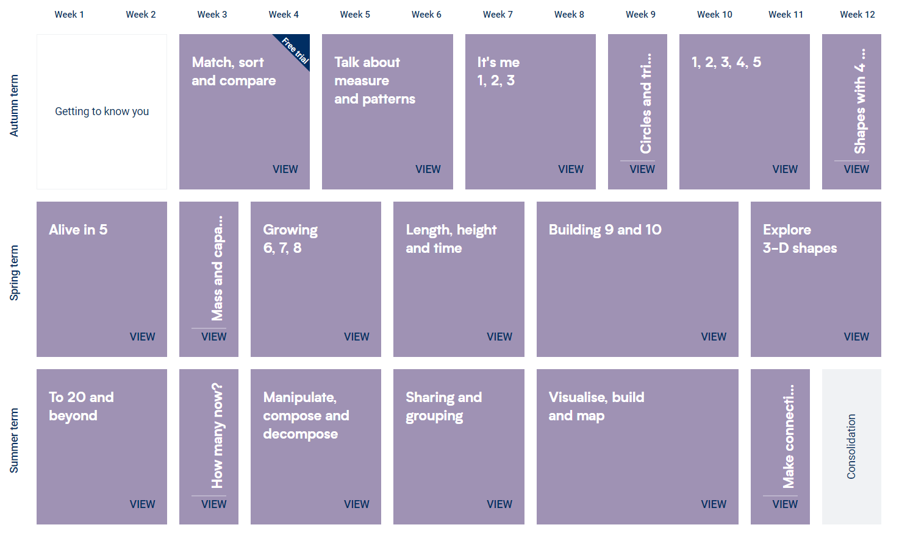

A Typical Day in EYFS
We know that children thrive in a well organised school. Therefore structure and routines are extremely important to us. Each morning the school gates open at 8:40am and our first session begins promptly a t 8:45am.
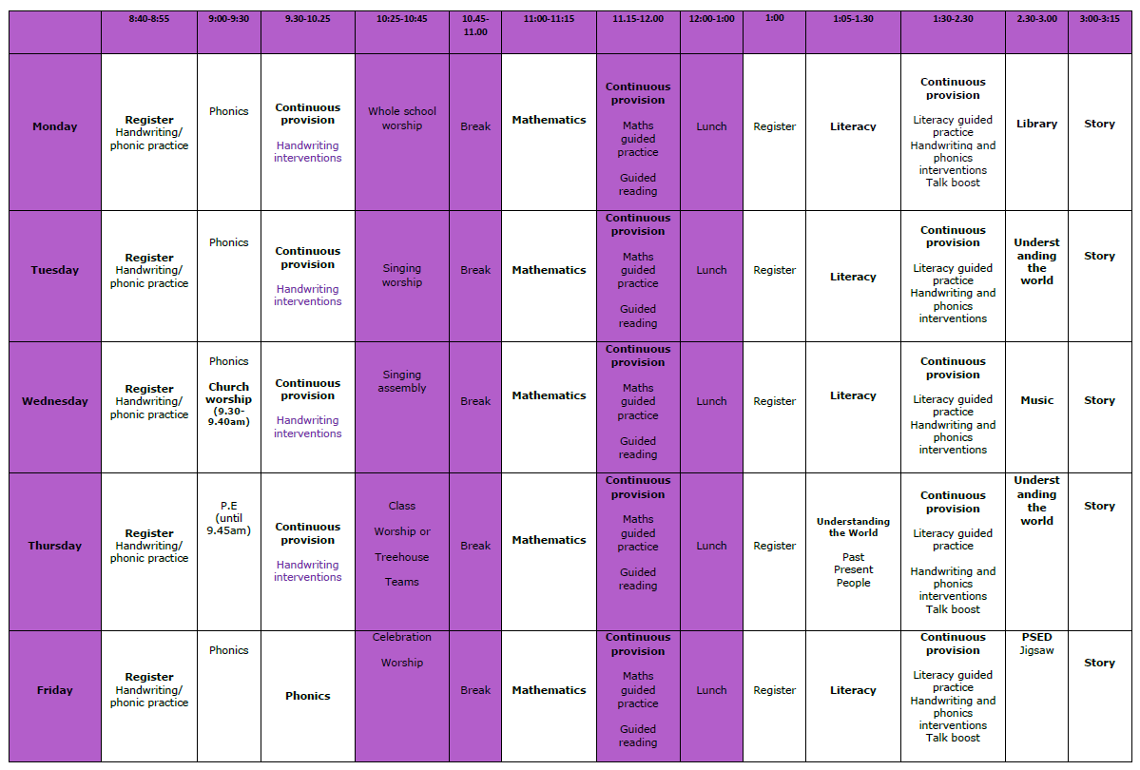
Working with Parents and Carers
We recognise that pupils’ learn and develop best when there’s a strong partnership between staff, parents and/or carers.
Parents and/or carers are kept up to date with their child’s progress and development through parents’ evenings. The EYFS profile and end of year report helps to provide parents and/or carers with a well-rounded picture of their child’s knowledge, understanding and abilities.
Transition from Nursery to Reception
Before children start with us at St Andrew’s Primary, we ensure that there is opportunity for children to spend time getting to know their teacher and explore the EYFS environment.
The class teacher also visits their nursery/preschool setting to get to know them and speak with their key worker.
The child is invited to attend stay and play sessions at the school with their key worker from their current setting.
A home visit is offered at the beginning of the academic year. This provides the teacher with an opportunity to see the child in their home environment and get to know their family.
Transition from Reception to Year 1
We believe that a smooth transition from Reception to Year One is important for a child’s next steps in their school life. Reception and Year One class teachers work closely together in Term 6 to begin this process.
We prepare Reception pupils by:
- Providing opportunities for the children to get to know their Year 1 teacher through story times at the end of the school day
- Having a ‘meet the teacher’ session where pupils formally meet their teacher, in their new classroom before the end of their Reception year
- Having circle time to allow children time to ask questions about the year ahead
- Altering the style of teaching and learning gradually, to familiarise pupils with a more formal approach to learning
- Providing a parent meeting in Term 6 of Reception
Special Educational Needs (SEND)
At St Andrew’s, we have an embedded and well-developed approach to supporting pupils’ with additional needs. Detailed information regarding out offer can be found in our SEND Report and Policy which can be found on the school website - https://standrewscongresbury.ovw3.devwebsite.co.uk/page/?title=SEND&pid=106

Policy Review
This policy will be reviewed following any major changes in legislation and/or every 2 years.

Headteacher’s signature: Date: 27/03/2025

Chair of Governor’s signature: Date: 27/03/2025


